Angular 7 Assessment Doc

Contents

1. Add JQuery to application 1

2. Add Bootstrap to application 1

3. Create Following components 1

4. Implement Routing 2

4.1. Default routing to HomeComponent. 2

4.2. UserList component with ‘userList’ path. 2

4.3. UserDetails component with ‘userDetails/:id’ path. 2

4.4. Any invalid URL must show PageNotFound component with Sorry, invalid URL text in <h1>. 2

5. Create User Creation Form 3

5.1. User JSON model 3

5.2. UI Validation 3

6. Create UserService 5

7. Create Custom Pipe MaskEmailId 5

8. Create Custom Directive 5

# Add JQuery to application

npm install --save jquery

# Add Bootstrap to application

Npm install --save bootstrap

# Create Following components

|  |  |  |  |
| --- | --- | --- | --- |
| **#** | **Component** | **Component Name**  **(*while creating components through angular cli use following name as is*)** | **Comments** |
| 1 | Home component | Home | Default route, when user hit index page, the default component would be HomeComponent |
| 2 | User creation component | UserCreation | This will contain a form to create a new user. So, will hold form markup which accepts the details for creating user. |
| 3 | User List component | UserList | All the users will be displayed on this page, as a list. |
| 4 | User Details component | UserDetails | When user selects a particular user from UserList component, the Id will be passed to UserDetails component and the specific details will be shown on this page.  The details of the specific user. |
| 5 | Page not found | PageNotFound | When user enters any invalid url, this page should be shown with <h1> Sorry ! Invalid Url |

# Implement Routing

## Default routing to HomeComponent.

## UserList component with ‘userList’ path.

## UserDetails component with ‘userDetails/:id’ path.

## Any invalid URL must show PageNotFound component with Sorry, invalid URL text in <h1>.

Links for each component are provided on app.component.html. Put **appropriate** **router directives** to make it work.

Route Configuration

|  |  |  |
| --- | --- | --- |
|  | Component | Path |
|  | HomeComponent | ‘’ |
|  | UserCreationComponent | ‘userCreation’ |
|  | UserListComponent | ‘userList’ |
|  | UserDetailsComponent | ‘userDetails/:userId’ |
|  | PageNotFoundComponent | ** |

**Milestone 1 completed**: Hurreyyyyy routing is working ….☺

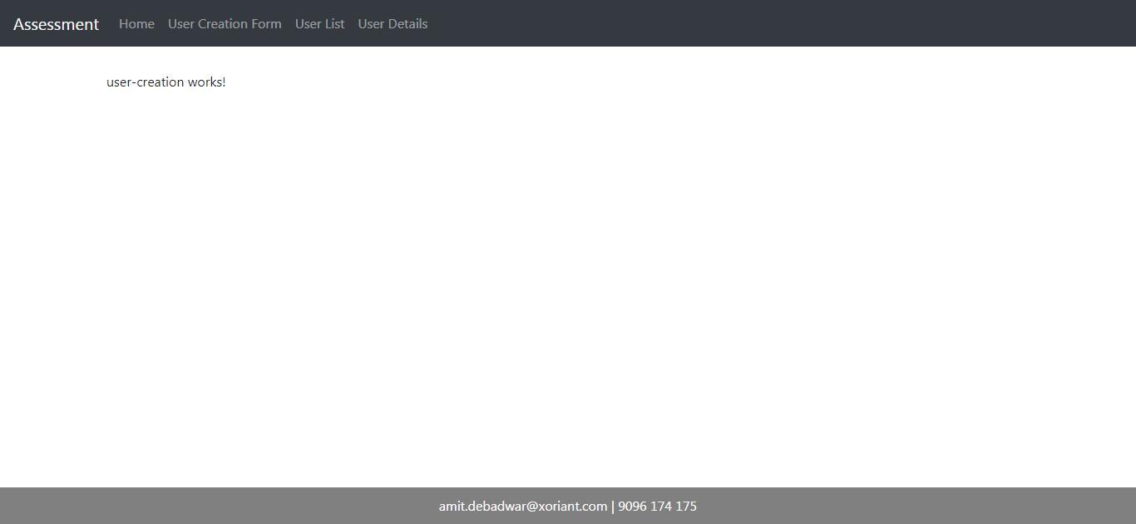

# Create User Creation Form

## User JSON model

{

"id": 1,

"name": "Amit Debadwar",

"username": "amit.debadwar",

"email": "amit.debadwar@xoriant.com",

"address": {

"street": "Blue Ridge Hinjewadi",

"city": "Pune",

"state": "Maharashtra",

"zipcode":"411057"

},

"phone": "1-770-736-8031 x56442"

}

## UI Validation

1. First name (text)
   1. Required field
   2. Only alphabets are allowed.
2. Middle name (text)
   1. Only alphabets are allowed.
3. Last name (text)
   1. Required
   2. Only alphabets are allowed.
4. Which UI Framework have you worked on (radio)
   1. Required field (one must be selected)
5. Which backend technology you are familiar with.(checkbox)
6. Email (email)
   1. Required
   2. A valid email address check
7. Cell Number (text)
   1. Required
   2. Only digit allowed
   3. Minimum length and maximum length is 10 character long.
8. Current Address (text area)
   1. Required
9. Permanent address (text area)
   1. Required.
   2. If selects the checkbox “same as current address” then current address should be populated in permanent address with read-only field.
10. City (select)
    1. Required
    2. Must be selected
11. State (select)
    1. Required
    2. Must be selected
12. Zip (text)
    1. If entered then min max length must be 6 digits.
13. Submit button
    1. should be disabled on the page load.
    2. On success, show success message to user
    3. On error, show error message to user

Check all the validations are working properly

**Milestone 2 Completed**: Hurreyyyyy UI validations working ….☺

# Create UserService

Create user service with following methods.

1. getAllUsers() -- get
2. createUser() -- post
3. getUserDetails(id) – get (with url parameter)
4. deleteUser(id) -- delete

use jsonplaceholder’s /users API for **GET/POST/DELETE** verbs.

API : [**https://jsonplaceholder.typicode.com/users**](https://jsonplaceholder.typicode.com/users)

# Create Custom Pipe MaskEmailId

If email id is [amit.debadwar@gmail.com](mailto:amit.debadwar@gmail.com) then mask first 5 letters with *

e.g. *****debadwar@gmail.com

And apply filter on user list view.

# Create Custom Directive

When user enters mobile number without country code, when he enters 10 digits then format input field it self with +91.

e.g. 9096174175 => +91 9096 174 175

# Create Reusable ActionButtonComponent

This component, accepts the fontConfig and outputs the eventEmitter for hosting component.

Use this reusable component button on user list table for user details icon and delete icon.